* Brief Articulation of your chosen topic and rationale

We want to create an app that allows a user to input their alcoholic drinks that they’ve consumed recently as well as their location and biometrics. The output is a calculation of the ABV of their drinks and their BAC. Based on BAC, a map will populate Bars (if under .08) and/or Transportation services (if over .08). There will also be a pie chart that provides popular recommendations based on input.

* A link to your dataset(s) and a screenshot of the metadata if it exists.

Link to Drink Recipes:

<https://www.thecocktaildb.com/api/json/v2/9973533/search.php?s>

Link to Alcohol Content:

<http://www.alcoholcontents.com/liquor/>

Google JS for Transit Layer:

<https://developers.google.com/maps/documentation/javascript/examples/layer-transit>

Reference for BAC Calculator:

<http://www.umsl.edu/~munsr/javascript/summer2001/bac.html>

Optional Items:

Drinks by State with Map reference

<https://www.insider.com/most-popular-cocktail-in-every-state>

Explanation of BAC Levels:

<https://awareawakealive.org/educate/blood-alcohol-content>

* 3 or 4 screenshots of relevant, “inspiring” visualizations that frame your creative fodder.
* Dashboard for App

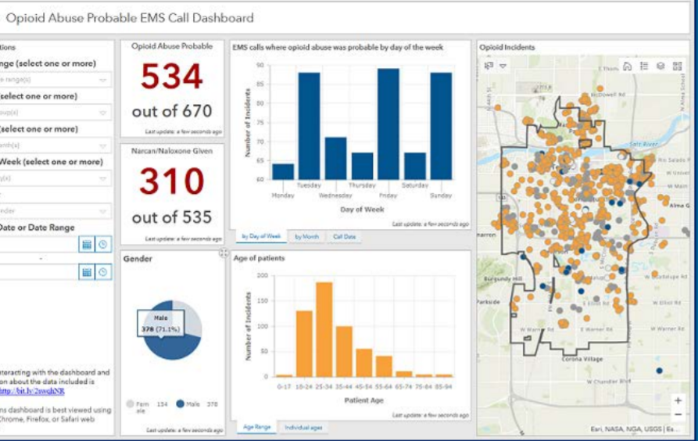

-Visualization for BAC and notes:

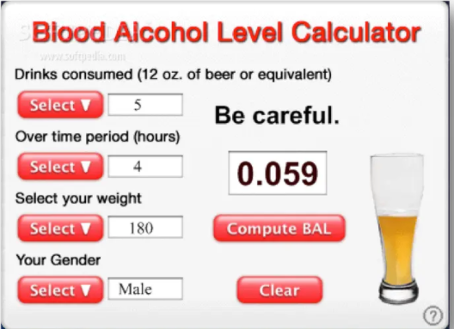

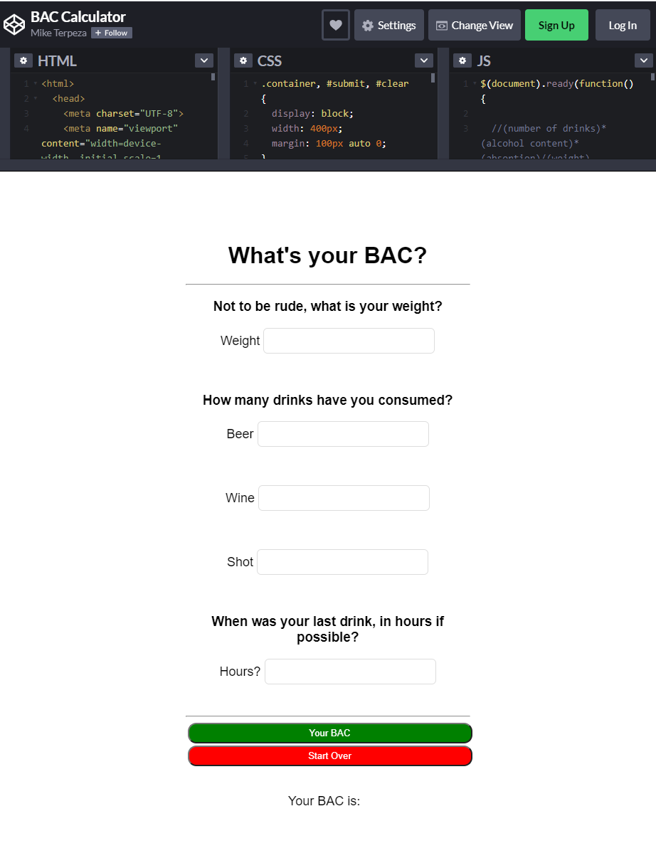

-Bubble Map for Liquors:

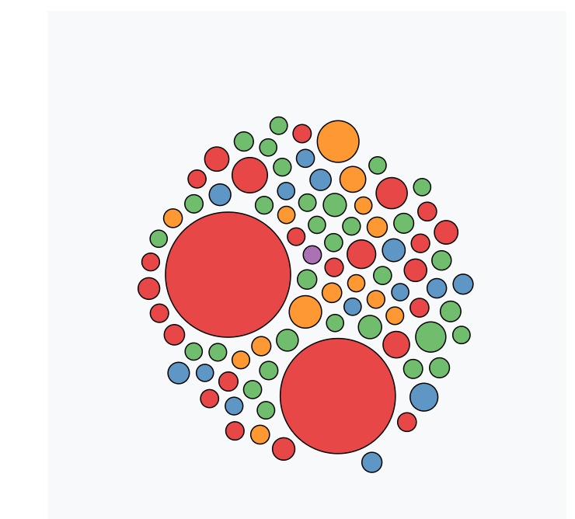

* A sketch of the final design

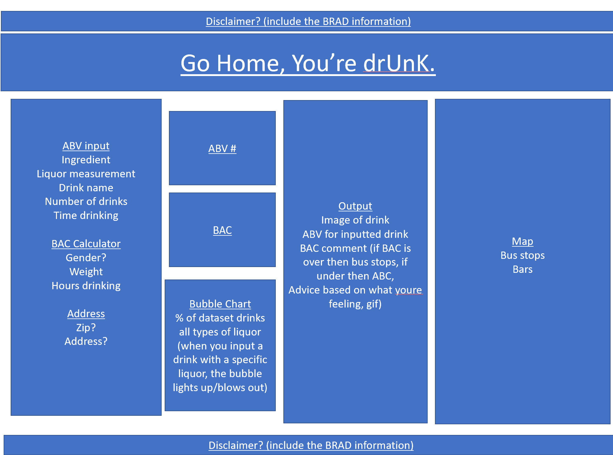

* Javascript Library we have not used:

<https://validatejs.org/> - We will be using this for input validations for all inputs.

* Database Choice:
* We will be utilizing SQL DBs
* A link to the primary GitHub repository you’ll be housing your work in:

<https://github.com/rclassit/Project-2.git>